Ex.no:2 | EDA-DATA IMPORT AND EXPORT

Aim:
To inspect dataset features, detect null values, and export data into CSV, Excel, and SQLite database formats.
Algorithm:
- Import pandas and sqlite3 libraries.
- Read hotel_bookings.csv using pd.read_csv().
- Inspect data structure using .head(), .tail(), .info(), .describe(), and .isnull().sum().
- Export DataFrame to .csv and .xlsx formats using .to_csv() and .to_excel().
- Connect to hotel_booking.db using sqlite3 and write data into an SQL table via .to_sql().
- Close the database connection and end execution.

Program:
# Import required libraries

import pandas as pd

# Load the Patient Medical Appointment dataset

df = pd.read_csv("KaggleV2-May-2016.csv")

# Display the complete dataset

print("===== DATASET =====")

print(df)

# Display first five records

print("\n===== FIRST FIVE ROWS =====")

print(df.head())

# Display last five records

print("\n===== LAST FIVE ROWS =====")

print(df.tail())

# Display dataset information

print("\n===== DATASET INFORMATION =====")

print(df.info())

# Display statistical summary

print("\n===== STATISTICAL SUMMARY =====")

print(df.describe(include='all'))

# Display dataset shape

print("\nDataset Shape:", df.shape)

# Display column names

print("\nColumns:")

print(df.columns)

# Check missing values

print("\n===== MISSING VALUES =====")

print(df.isnull().sum())

# Export dataset to CSV

df.to_csv(
"patient_appointment_export.csv",
index=False
)

print("CSV file exported successfully!")

# Export dataset to Excel

df.to_excel(
"patient_appointment_export.xlsx",
index=False
)

print("Excel file exported successfully!")

import sqlite3

# Create SQLite database

conn = sqlite3.connect("patient_appointment.db")

# Export DataFrame to SQL table

df.to_sql(
"patient_appointments",
conn,
if_exists="replace",
index=False
)

print("Dataset exported successfully to SQLite database!")

conn.close()
Output:
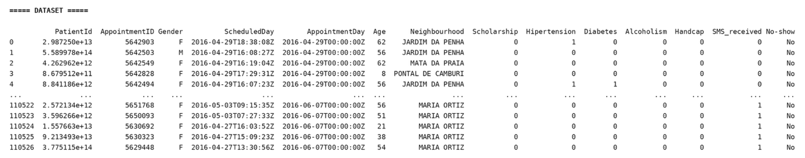
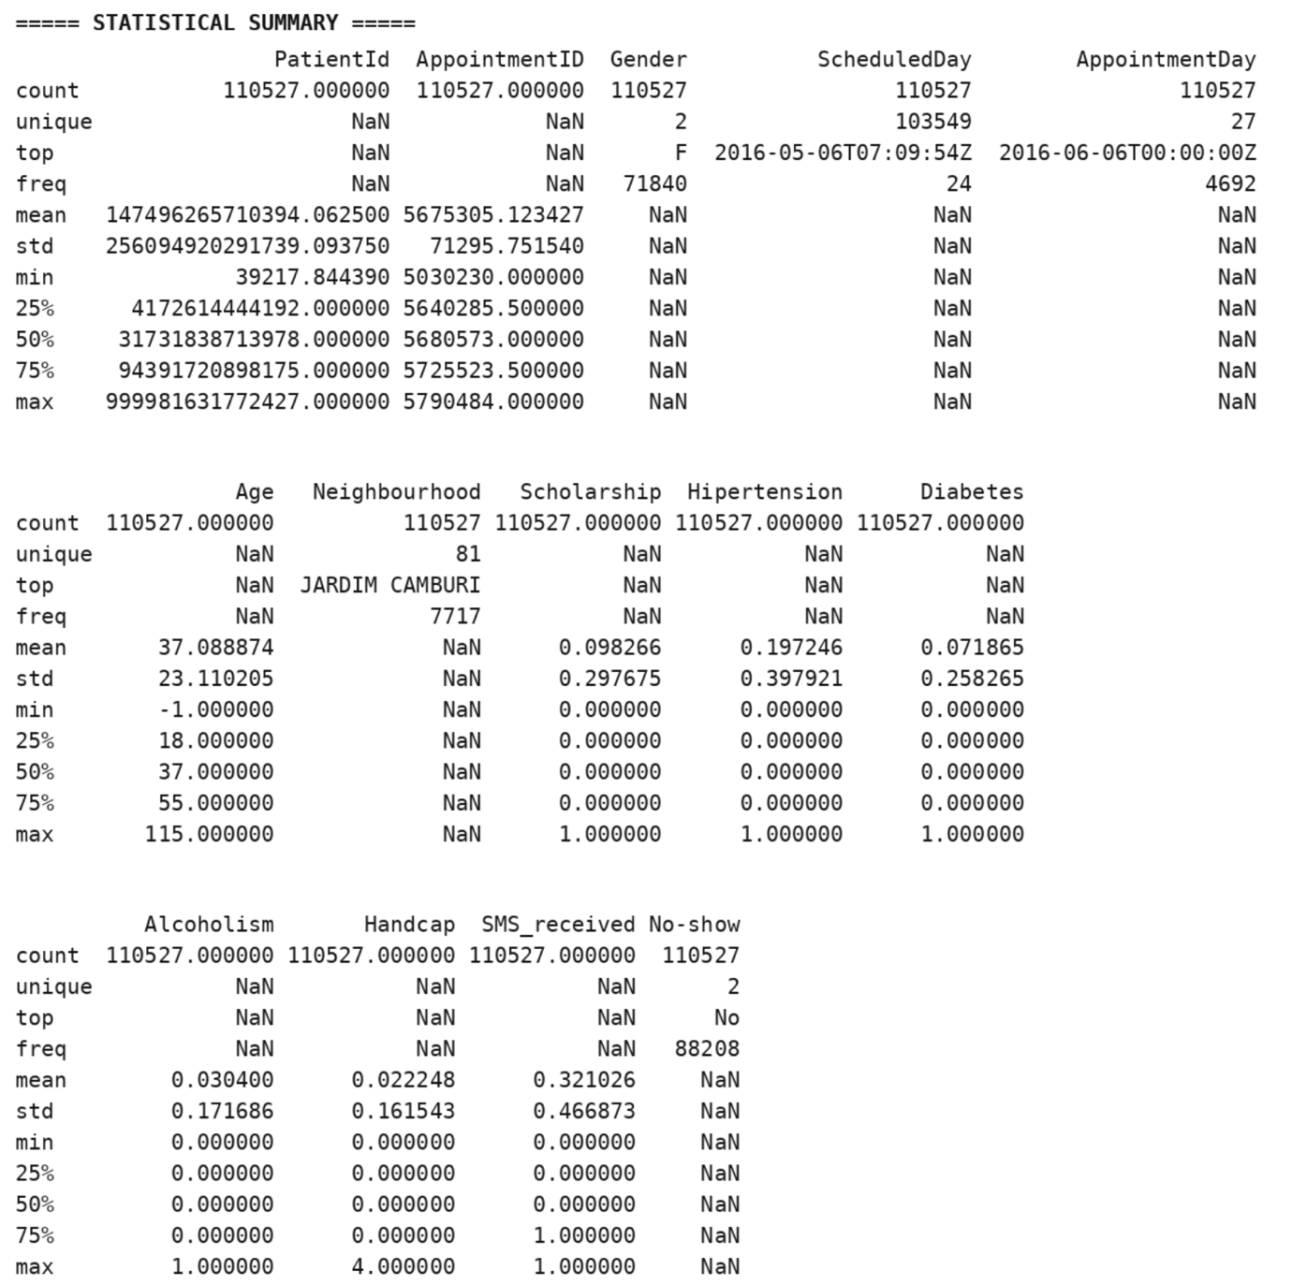

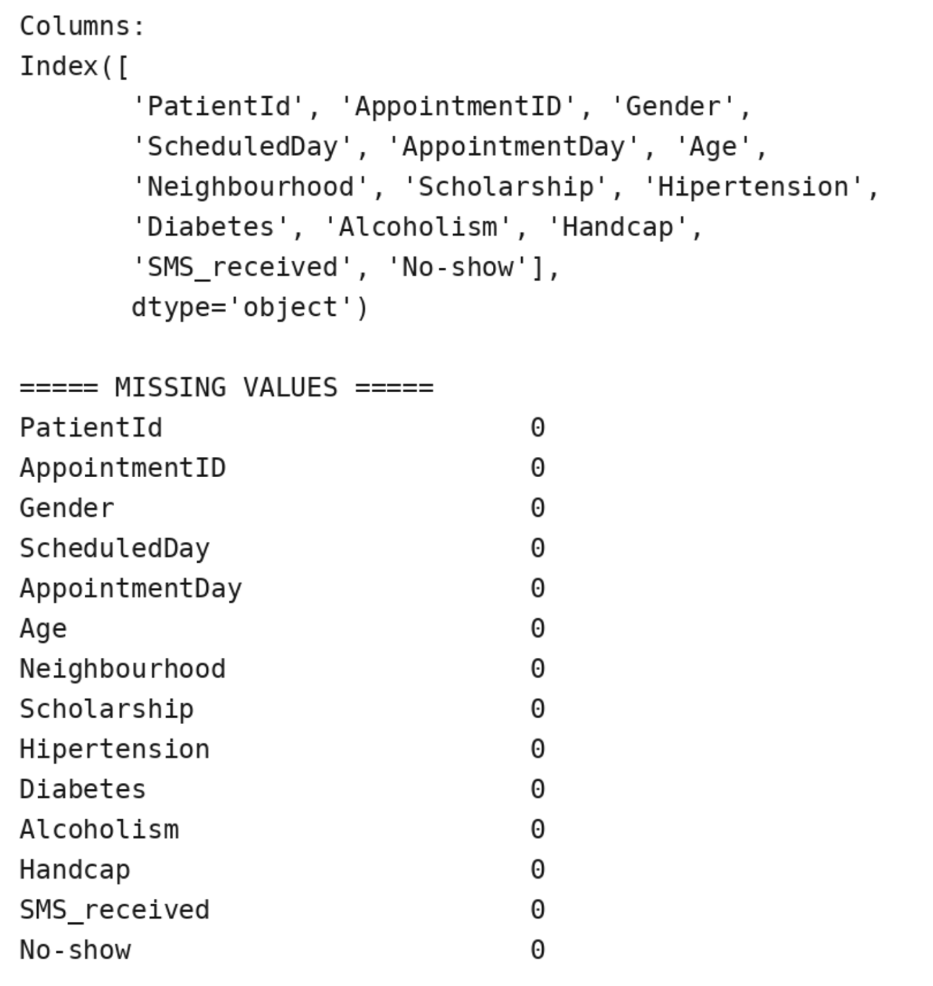

Result:

